Video Game Review

By Gabriel Boyer

Blox Fruit is an anime video game. Based on One Piece, you can collect swords and devil fruits to become more powerful. After this, you can put your abilities to use in player vs. player (pvp) or grinding new items. I’m going to be going over the player vs. player version. You will not be good at Blox Fruit pvp if you do not use combos, kentrick, and unpredictable movements.

Combos: If you do not use combos on your enemy, your pvp matches will be much longer. The reason for that is because instead of using one attack for 2000 to 9000 damage, you can use a burst of all of your attacks at once and finish them off right there.

Kentrick: If you do not know what a kentrick is, it's when you don't use observation hockey until your enemy starts a combo. Then, you have to predict when they use a dodgable move. Finally, if the positioning lines up right after you dodge, you can punish your enemy with your own combo.

Unpredictable movement: To have unpredictable movement, you must have no dash patterns. If you do that correctly, your enemy can't hit you across the map.

If you do all of the above correctly, it should make you much better or extremely good at Blox Fruit pvp.

DRAGON REWORK

Aleksi Peinik

Blox Fruit is a fun player vs.player (pvp) game. Blox Fruit takes your money because it is such a good game. Recently, there have been leaks of a new update.

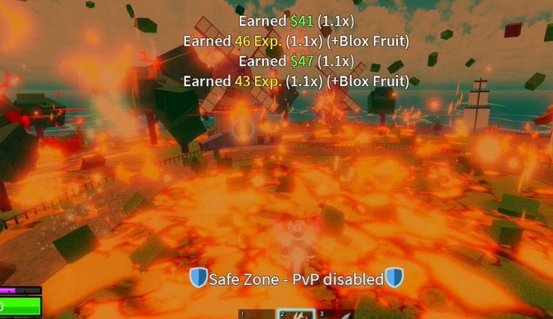

An admin called Rip_Indra posted a picture of the rework dragon on December 15, 2023. This is a picture of one of the moves. I'm guessing it is the after effect of the move.

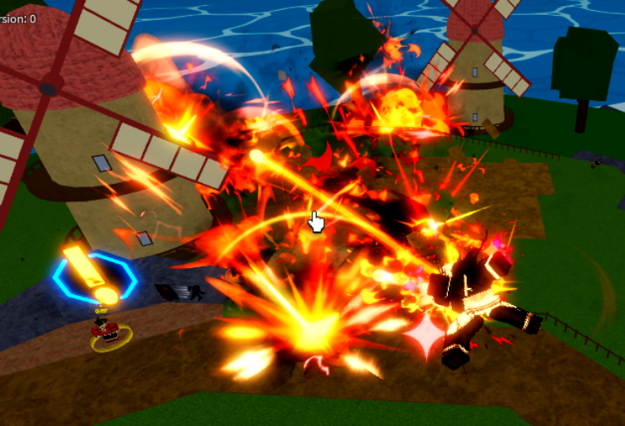

And a 2nd leak on another move on dragon on Mar 16,2024. The moves are showing a player getting better moves.

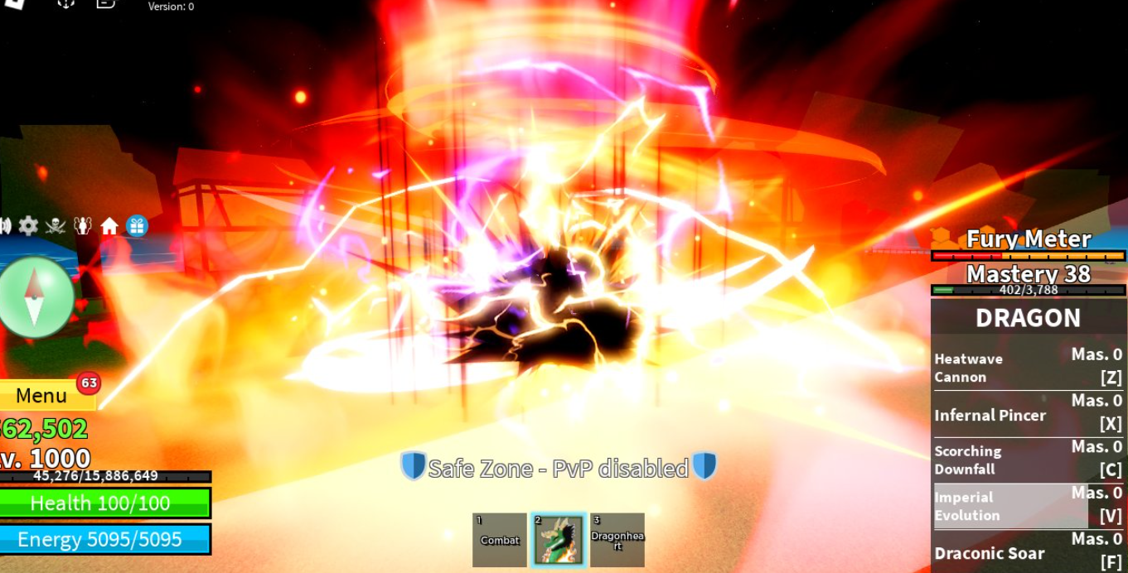

Then on Mar 22,2024, there was a transformation, and at the bottom of the screen you can see something called the dragon. We still don't really know what it's for.

Keep reading for more updates!

COOL RIDDLES!

By: Anais Moore

1. What is a treasure chest that doesn’t have a key or a keyhole but has a golden treasure inside?

2. 13 white horses are on à red hill, first they chomp, then they stomp, then they stay still. What are they?

3. What wilts flowers makes mountains grow & kills all living things

4. If you put a coin in a bottle then close it with a cork then how do you get the coin out without pulling the cork out or breaking the bottle.

Answers:

1. An egg! The golden treasure is the yoke and the only way to get

inside is to break it !

1. Teeth! The white horses are the teeth and the red hill is our gum.
2. Time! The mountains get slowly taller and living things don’t live forever.

1. Push the cork in the bottle then turn it upside down then gravity will pull the coin to the opening.

Video game review:

By: Chloe Kull

Right now, I’m going to talk about video games so you can get updated on the newest things. We’ll start off this text with the top 10 video games:

-1# Legends of Zelda, Ocarina of Time

-2# Soul Calibur

-3# Grand Theft Auto IV (GTA 4)

-4# Super Mario Galaxy

-5# Super Mario Galaxy 2

-6# Legends of Zelda, Breath of the Wild

-7# Tony Hawk’s Pro Skater 3

-8# Red Dead Redemption 2

-9# Grand Theft Auto V (GTA 5)

-10# Metroid Prime

Personally, I prefer Splatoon, but you guys can choose your favorite. As these may be the top 10, we might have to make room for the newest ones like: Star Wars Outlaws, Dragon’s Dogma 2, and Paper Mario Thousand-Year Door. Forget about that- now let’s hear about the newest video game updates like Minecraft update 1.20.5, Blox Fruits dragon fruit rework, and the Fortnite Billie Eillish update. The most widely-sold video game is a classic, Tetris. Well, that’s all the news I have. 🎮

**Cruella, A good movie ?**

*By Charlee Blain*

The movie Cruella is a live action movie and it is obviously Disney. It was released in 2021. The movie is 2h14m long. It’s classified as PG-13, and you can watch it on Disney and Youtube. The actress who plays Cruella is Emma Stone. The movie explains how Cruella became Cruella and why she is Cruella. The movie also got awarded “Best Costume Design” in 2021. The moral of the movie is “ The more times we fall, the more times we rise.” ( Cruella, 2021)

In my opinion, it is a wonderful movie with a beautiful story. It is a little sad, but not enough to make you cry. I also love the music choices ! What happens? Watch the movie to know !

Blobfish!

Elise Kull

What has no bones, is almost flat, and has no muscles? A Blobfish!

These fascinating animals are 12 inches long, they have no teeth and can’t feel pain. When you see them they are the most ugly animal you can ever see! They can stretch out like slime.

A Blobfish can live down 3,900 feet in Oceania. They live there for a long time because they live to be 130 years old! They can explode as a survival method. Blobfishes also lay eggs.

Fortunately, they are not venomous so we can study them. There are 9 types of them. To eat them, you need a blowtorch. We need to save the amazing Blobfish because there are only 420 left! They really are amazing.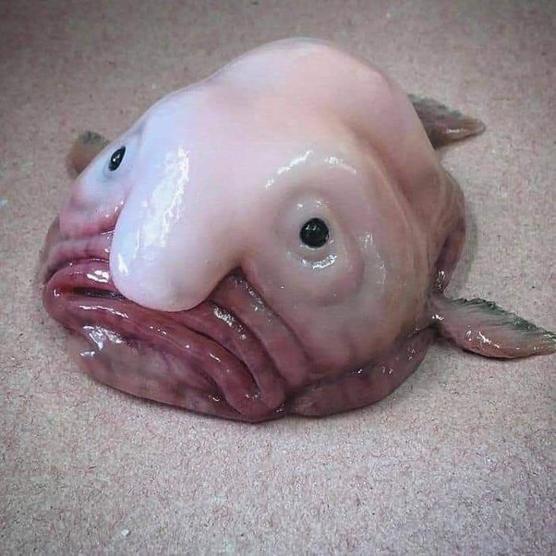

Eternal Sunshine

**Iris Mahous**

Ariana Grande, also known as “The queen of Pop,” has made a new album. It came out on March 8 2024, and contains 13 songs. The name of this album is “Eternal Sunshine,” and it’s her 7th album. Ariana Grande declared:

*“hi i just wanted to say anyone that is sending hateful messages to the people in my life based on your interpretation of this album is not supporting me and is absolutely doing the polar opposite of what i would ever encourage,” (Ariana Grande, Google)*

One of her new album songs is titled: “We can’t be friends.” Which buzz marked as “The best song of Eternal Sunshine.” Now, you can go buy it right now or go listen to it!

Blox Fruit Tips

By Jean Guillhem

When playing the Blox Fruit computer game, here are the best combos with Kitsune Blox Fruit to fight your enemy:

1 First use Darkblade z, they are stunned.

2 Switch to Kitsune and press Z X C next.

3 Kitsune F next.

4 Godhuman Z godhuman C godhuman X next.

5 Kitsune Z AND X that is the finisher move.

6 After, if they are not dead, you can do Kitsune spammer to finish.